Infographic

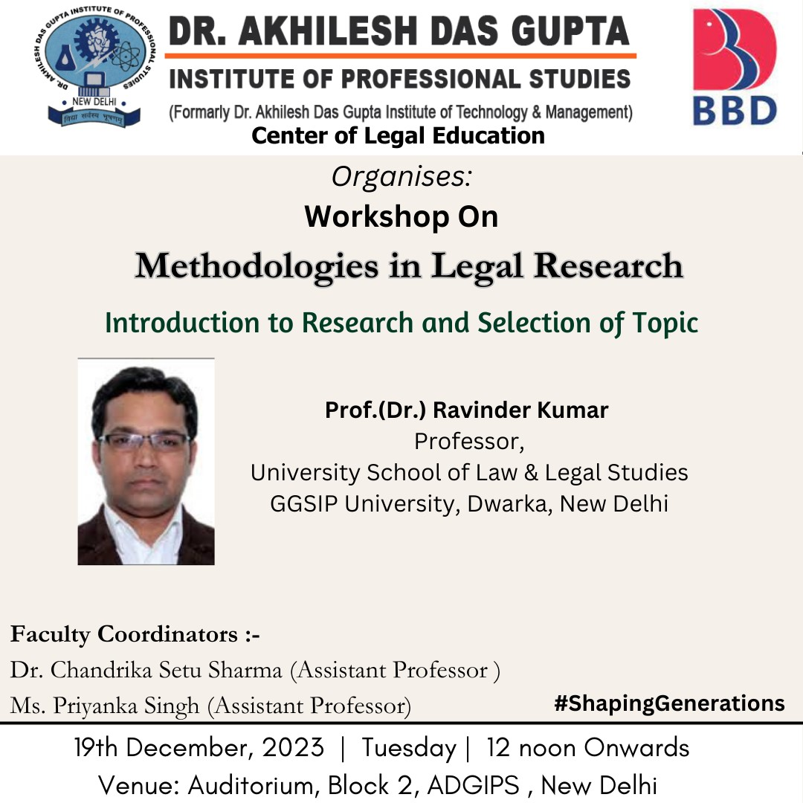

Dr. Akhilesh Das Gupta Institute of Professional Studies
CENTRE OF LEGAL EDUCATION

A REPORT ON WORKSHOP
Topic: Methodologies in Legal Research
Theme- Introduction to Research and selection of Topic

Date: 19.12.2023
Day: Tuesday
Time: 12:00 P.M Onwards
Venue: Auditorium

Objective:

The session projects to provide in depth training to the B.A.LL.B (H) B.B.A.LL.B (H) students of first and third Semester.
The objectives of the workshop were:
- to inculcate the knowledge on the fundamentals of research
- to build the perceptive on how to select a topic
- to disseminate knowledge on research design, application & data analysis

Brief Report:

The workshop started with the inauguration ceremony by lighting of lamp. The program was inaugurated by the Resource Person Prof. (Dr.) Ravinder Kumar, Professor, USLLS, GGSIP University, Prof. (Dr.) Sanjay Kumar, Director, ADGIPS, Mr. B.M.K Gupta, Director Finance, Dr. Navneet Kansal, Principal, CLE, ADGIPS, Prof. (Dr.) Niranjan Bhattacharya, Director IQAC along with Faculty Coordinators Dr. Chandrika Setu Sharma, Assistant Professor, CLE, ADGIPS and Ms. Priyanka Singh, Assistant Professor, CLE, ADGIPS followed by felicitation ceremony.
The Concept note was delivered by Dr. Navneet Kansal, Principal, CLE, ADGIPS wherein he introduced the importance and relevance of the two days Workshop on Methodologies in Legal Research to the audience. Further, Ms. Priyanka Singh, Assistant Professor, CLE, ADGIPS introduced the profile of the Resource Person Prof. (Dr.) Ravinder Kumar, Professor, USLLS, GGSIP University.

Thereafter, technical session 1 was handled by the speaker Prof. (Dr.) Ravinder Kumar, Professor, USLLS, GGSIP University. He started the session by making the students aware about how to select a topic and stated that selection process involves evaluating the feasibility of the research, considering available resources, and anticipating potential challenges. It requires a balance between a topic's breadth and specificity, ensuring that it is neither too broad to hinder in-depth exploration nor too narrow to limit available literature. A well-defined research area or topic lays the groundwork for a focused and meaningful inquiry, setting the stage for a comprehensive and rigorous exploration of the chosen subject matter.
He further added the questions of why, who, what, where, and when to cover while doing research. He elaborated on the concept of converting ideas into research topics. He mentioned that maintaining a discerning equilibrium in this undertaking is of paramount importance, allowing for a comprehensive and in-depth exploration within manageable parameters. This intentional narrowing down of the research focus not only mitigates the risk of generality but also facilitates a more nuanced and rigorous examination of the selected topic.
Lastly, he concluded with the very effective and efficient concept and acronym FRIENDS: the essence of topic selection which is formed by using the first letter of the word captures the essence of topic selection criteria. Additional words or phrases on the right side corresponding to these words act as the pointers to the details of each word.
At the end of the session all the questions of the audience were patiently addressed by the speaker.
Learning Outcome:
The workshop turned out to be a rich experience for the participants, raising their confidence to proceed with research and produce quality output.
Participants were benefitted to understand on how to select the topic and go forward in the research.

Beneficiary: B.A.LL.B (H) B.B.A.LL.B (H) students of first and third Semester and Faculty Members.

GLIMPSES OF THE EVENT
