Infographic

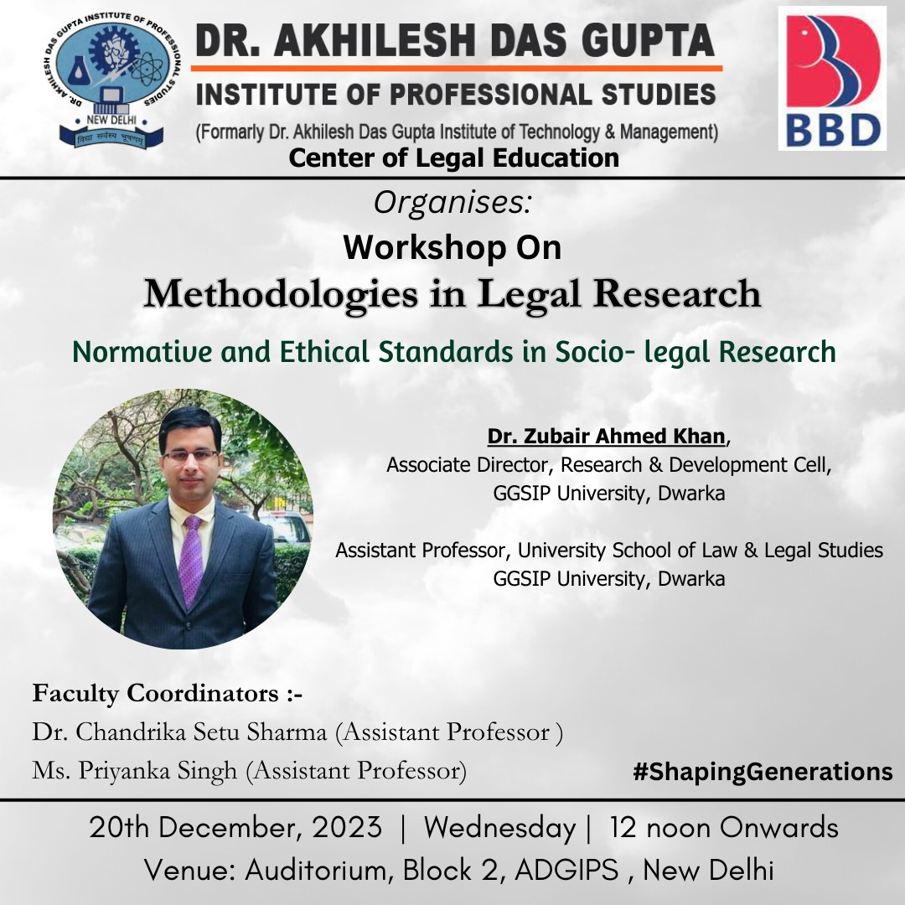

Dr. Akhilesh Das Gupta Institute of Professional Studies
CENTRE OF LEGAL EDUCATION

A REPORT ON WORKSHOP
Topic: Methodologies in Legal Research
Theme: Normative and Ethical Standards in Socio-Legal Research

Date: 20.12.2023
Day: Wednesday
Time: 12:00 P.M Onwards
Venue: Auditorium

Objective:

The session projects to provide in depth training to the B.A.LL.B (H) B.B.A.LL.B (H) students of first and third Semester.
The objectives of the workshop were:
- To develop the understanding on the research ethics and plagrism
- to develop skills for synopsis/thesis development & academic writing

Brief Report:

The workshop started by welcoming the Resource Person Dr. Zubair Ahmed Khan Assistant Professor, USLLS, GGSIP University by Prof. (Dr.) Sanjay Kumar, Director, ADGIPS, Mr. B.M.K Gupta, Director Finance, Dr. Navneet Kansal, Principal, CLE, ADGIPS, Prof.(Dr.) Niranjan Bhattacharya, Director IQAC along with Faculty Coordinators Dr. Chandrika Setu Sharma, Assistant Professor, CLE, ADGIPS and Ms. Priyanka Singh, Assistant Professor, CLE, ADGIPS followed by felicitation ceremony.
Further, Dr. Chandrika Setu Sharma, Assistant Professor, CLE, ADGIPS introduced the profile of the Resource Person Dr. Zubair Ahmed Khan Assistant Professor, USLLS, GGSIP University.
Thereafter, technical session 2 was handled by the speaker Dr. Zubair Ahmed Khan Assistant Professor, USLLS, GGSIP University.
He started the session by introducing the Normative Approaches to Study of Law. He explained the rules and guidelines that define the conduct of a researcher. He added that researchers should protect the dignity of their subjects and publish well the information that is researched and Ethical research must conform to the national and international accords and prescripts.
He further added Nuremberg code 10 Ethical principles of Law. Furthermore, he explained the concept of Plagarism. He quoted the examples of forms of plagiarism that include Verbatim Close paraphrasing of another’s work by simply changing a few words or altering the order of presentation, Deliberate and detailed presentation of another’s concept as one’s own. He also touched upon the levels of Plagarism like minor Plagarism, major Plagarism and collusion.
He also discussed the laws on plagiarism that is available wherein he explained section 57 and 63 of Indian Copyright Act. He explained the University Grants Commission (Promotion of Academic Integrity and Prevention of Plagiarism in Higher Educational Institutions) Regulations, 2018.
Lastly, he shared the different methods to curb Plagarism where he gave expels that all HEIs are to implement a mechanism in order to detect plagiarism at the time the scripts are submitted to the institution. Also every student who is submitting such scripts must also provide an undertaking which says that the work is original and no content has been plagiarized. Also he added that members of the faculty, Ph.D. or M.Phil students are to be given access to such plagiarism detection tool.
At the end of the session questions of the attendees were addressed by the resource person. The presentation of the session was shared with the students.
Learning Outcome:
The workshop helped the participants understand the nuances of writing and presenting quality research work. The participants got well versed with the Normative and Ethical standards of Socio-Legal Research.
The event was a great success in terms of generating enthusiasm and interest among the students as reflected in their active participation in the event.
The workshop was applauded and appreciated by all.

Beneficiary: B.A.LL.B (H) B.B.A.LL.B (H) students of first and third Semester and Faculty Members.

GLIMPSES OF THE EVENT

