Dr. Akhilesh Das Gupta Institute of Technology & Management
CENTRE OF LEGAL EDUCATION

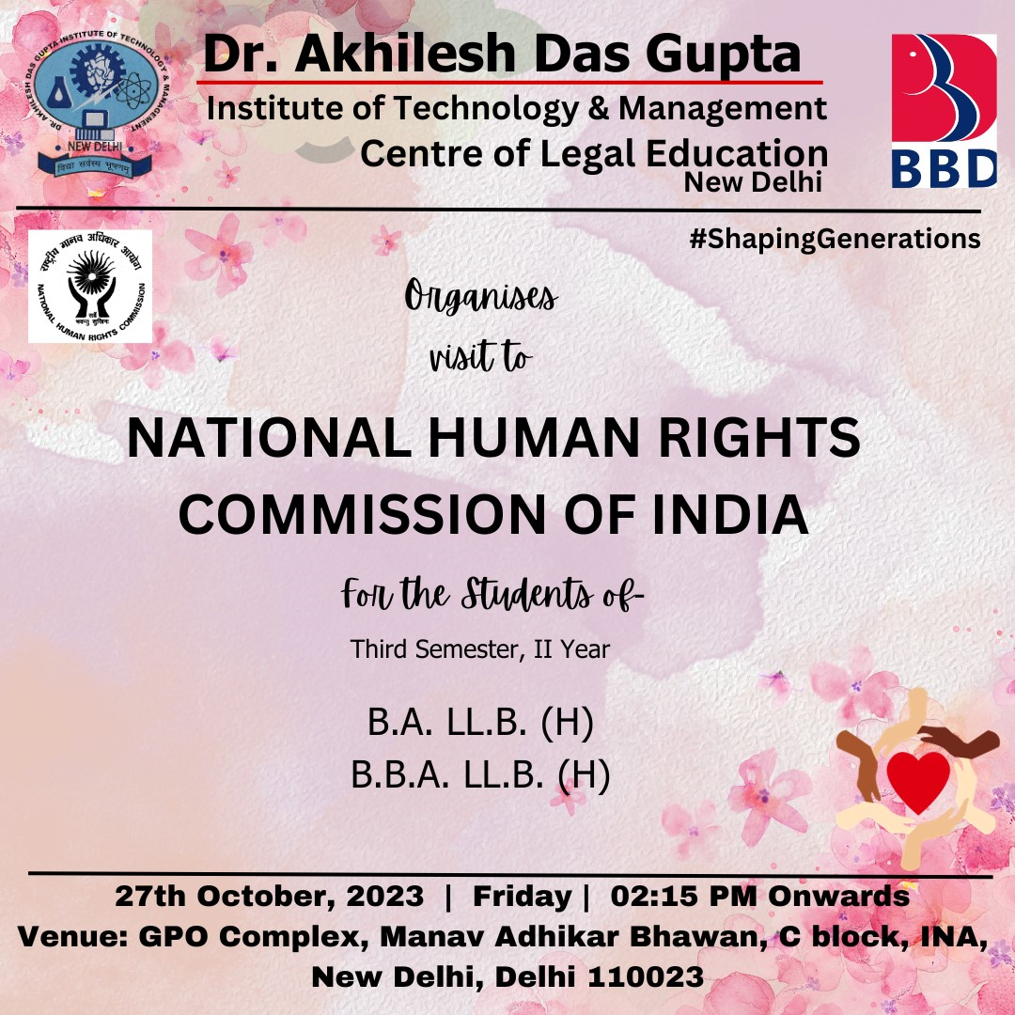

Dr. Akhilesh Das Gupta Institute of Technology & Management
CENTRE OF LEGAL EDUCATION

Date: 01.09.2023
Day: Wednesday

Report on Visit to National Human Rights Commission of India, New Delhi
The Centre of Legal Education organised a visit on National Human Rights Commission of India, New Delhi for the students of B.A.LL.B (H) and B.B.A.LL.B (H) of CLE Third Semester, Second Year on 27th October, 2023 from 2:30 p.m. till 5:30 p.m.
It was attended by 32 students of B.A.LL.B (H) and B.B.A.LL.B (H) of CLE Third Semester, Second Year along faculty co-coordinators Dr. Chandrika Setu Sharma, Assistant Professor, CLE, ADGITM and Ms. Kajal, Assistant Professor, CLE, ADGITM.
Objective:
The session aspired to protect and promote of human rights. The functions of the Commission as stated in Section 12 of the Act and apart from enquiry into complaints of violation of human rights or negligence in the prevention of such violation by a public servant, the Commission also studies treaties and international instruments on human rights and make recommendations for their effective implementation to the Government.
Brief Report:
The visit included lecture sessions. The sessions were divided into three lectures wherein, first lecture was addressed by Mr. Bipin Bihari Gautam, Presenting Officer, NHRC and Mr. Debindra Kundra Assistant Registrar, Law by addressing the students about basic functioning of NHRC by explaining in detail Section 12 of the Protection of Human Rights Act, 1993. The second session was addressed by Ms. Monia Uppal, DSP (Inv.), NHRC ma’am gave insights on the field investigation and the role and limitations of Investigation Officer of NHRC. Ma’am also shared her experience at the time of investigation. The third session was addressed by Mr. Sanjeev Sharma, Senior Systems Analyst, NHRC sir gave the presentation on HRCnet Portal and ICT works. Sir, gave the detailed explanation on the role of engineers in NHRC and how successful they have been by creating the online portal HRCnet wherein they cover every minute details of the cases and how effectively the staff of NHRC/SHRC working.
The session ended by moderate round. The speakers were patient and addressed the query of the students in detail.

Learning Outcome:
The session aided in educating the attendees about the role and relevance of NHRC.

GLIMPSE OF THE EVENT

