Dr. Akhilesh Das Gupta Institute of Technology & Management
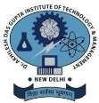
MBA DEPARTMENT
Tittle: Guest Lecture on the topic “Innovation in Personal Financial Management – A Lesson to the budding leaders of tomorrow”
Date: 7th October, 2022
Department: MBA Department
Mode: Online
Objectives: To help students to know about Personal Financial Management and its spectrum and how it is evolving with the help of latest trends.
Speaker: Dr. Sharan Kumar Shetty, Associate Professor, Head & International Relations MSNIM, Mangaluru
Activities Undertaken: MBA Department Of Dr. Akhilesh Das Gupta Institute of Technology and Management conducted a Guest Lecture on 7th October, 2022 from 2:15 PM onwards. The resource person, Dr. Sharan Kumar Shetty spoke on the topic of “Innovation in Personal Financial Management – A Lesson to the budding leaders of tomorrow”.
The session started with a warm welcome of Dr. Sharan Kumar Shetty by Prof. (Dr.) Divya Gangwar, Head of Department. His career contours nearly two decades and demonstrates extensive Indian and International expertise along with consistent success in teaching, mentoring, and educational leadership. The session was very interactive and students participated enthusiastically.
Dr Sharan Kumar Shetty gave a brief introduction of the topic. Later he explained stock market returns, brokers, sub brokers, stock prices, precautions in the stock market etc. The participants exhibited their knowledge and participated with great passion and enthusiasm.At the end students discussed their views and cleared their doubts with the expert.
The vote of thanks was given by Department-In charge, Ms. Sonali Gaur who showed gratitude for his esteemed presence. According to the participants, it was a good learning experience and it helped them in understanding the latest trends in the industry of finance.
Beneficiaries: Students of MBA
Outcome: It was an informative session where students learnt about Personal Financial Management.

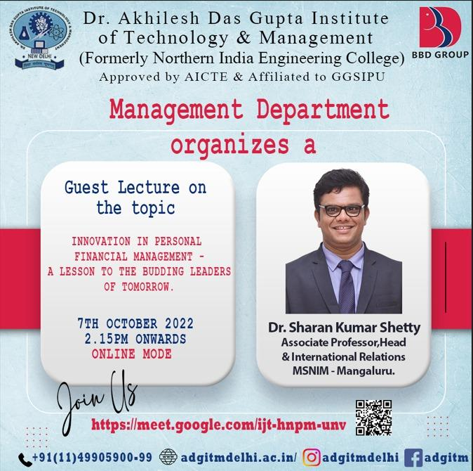
Screenshot:
