Dr. Akhilesh Das Gupta Institute of Technology & Management
MBA DEPARTMENT
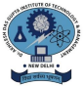
Event : Marketing Buzz
Date: 23rd Dec, 2022
Department: MBA Department
Venue: Room no. 2402 , Block -2 , ADGITM
Event Organizer: Sankalp Society (MBA Department)
Guest: Dr. Tanuja Nautiyal
Activities Undertaken: Technofest Sankalp Society of MBA department, ADGITM organized a Management Buzz Event on Dec 23th, 2022 from 10:00 AM onwards. The session started with a warm welcome of Dr. Tanuja Nautiyal, Head- examination, Prof. (Dr.) Divya Gangwar, Head- Management department and Ms. Aastha Event incharge. Dr. Tanuja Nautiyal delivered a speech to the students and motivated them to participate in such activities. Mr. Aman Garg and Ms. Komal were the judges of the event. In the beginning the host gave a brief introduction of the event “Management Buzz”. The event consisted of 3 Rounds (Round1: Tagline, Round2: Acting, Round3: Management quiz). The participants were from all the departments of ADGITM. The overall event was very interactive where the participants exhibited their knowledge and participated with great passion and enthusiasm.
At the end students discussed their views with the Judge's. As per the feedback received from the participants it was a very good learning experience. The session was very interactive and students participated enthusiastically.
Total Participants: 15 Groups
Winner : 3 Groups
Awards : Certificate and Cash Prize
Beneficiaries: Students of MBA Department
Outcome: It was an informative event where students learnt about Marketing. Brochure:
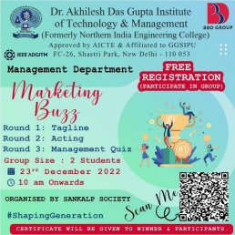Images From Events :
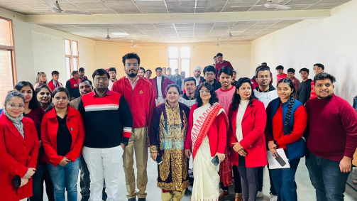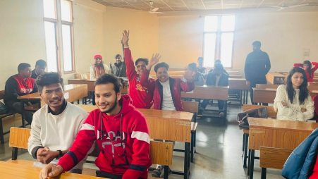
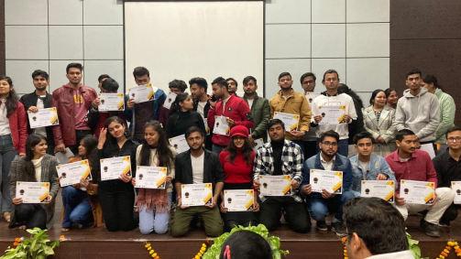
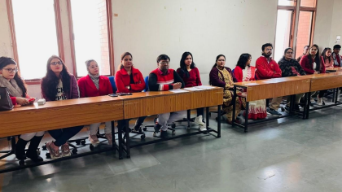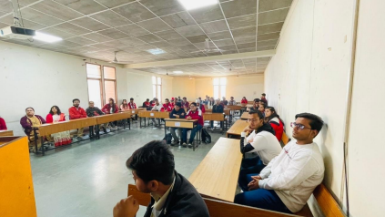s

