Dr. Akhilesh Das Gupta Institute of Technology & Management
MBA DEPARTMENT
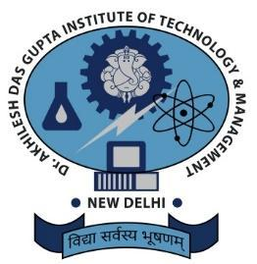
Tittle: Guest Lecture on the topic “Setting Smarter Goals”
Date: 7th November, 2022
Department: MBA Department
Venue: Auditorium
Objectives: How to Set Smarter Goals
Speaker: Prof. Ekta Rani Chauhan (IBS Gurgaon)
Activities Undertaken: MBA Department of Dr. Akhilesh Das Gupta Institute of Technology and Management organized a Guest Lecture on the topic of “Setting Smarter Goals” on 7th November, 2022 from 10:00 AM onwards. The guest lecturer of the event was Prof. Ekta Rani Chauhan, Soft Skill Faculty, IBS Gurgram.
The session started with a warm welcome of the Resource person Prof. Ekta Rani Chauhan by Prof. (Dr.) Divya Gangwar, Head of the Department. The session continued by Prof. Ekta Rani Chauhan by describing the importance of setting goals. All the steps of setting goals were listed and explained one by one in detail. Later she explained ideas about how to set goals, focus on efforts, use time and resources wisely for achieving future career and life goals. The overall Lecture was very interactive where the participants exhibited their knowledge and participated with great passion and enthusiasm
At the end students discussed their views with the expert. The vote of thanks was given by Ms. Aastha, Event Incharge of Management department. As per the feedback received from the participants it was a very good learning experience.
Beneficiaries: First year Students of MBA Department
Outcome: It was an informative session where students learnt about Setting Goals.

Brochure:
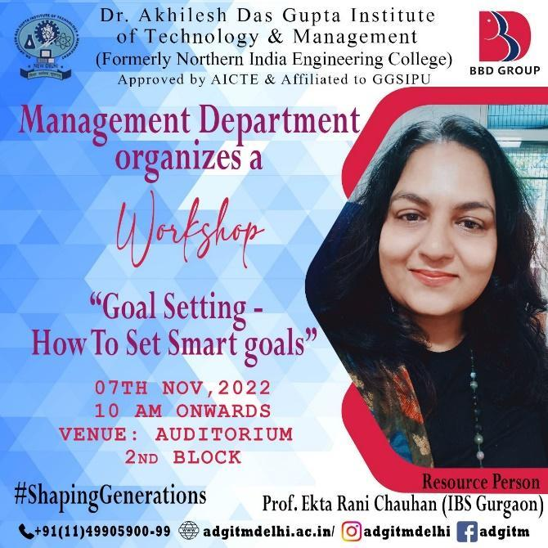
Images:
